**Indicators of a Healthy City: Medellin**

Medellin, Colombia’s second largest city, is widely regarded as one of the most innovative cities in the world, having undergone a tremendous transformation at the turn of the 21st century. It has gone from being one of the most dangerous cities in the world to a city that prides itself on the health of its people. This is, in part, due to a focus on equity, active citizen engagement (such as through participatory budgeting) and creative public investments, such as a cable car system and escalators that connect some of the poorest neighborhoods to the city’s heart.

The municipal government of Medellín conducts the Encuesta de Calidad de Vida (ECV) annually based on a multidimensional measure of fifteen dimensions. This project analyzed the city’s publicly available data across the fifteen indicators over a period of 2011-2018, to assess the city’s performance towards becoming a healthier city.

This analysis answers the following questions:

* **Performance:** How is Medellín performing on each indicator?
* **Improvement:** How has Medellín’s performance changed over time?
* **Equity:** How does performance differ by comuna, sex and estrato? Is the gap widening or closing?
* **Indicator Assessment:** What does this analysis tell us about the strength of the indicators used by the city as a measure of Medellín’s progression towards becoming a healthier city?

**Methodological Note:** This analysis was conducted in Python using publicly available raw data[1] on the fifteen indicators included in the IMCV, which measured the mean score for each comuna over an eight-year window from 2011-2018. First, we scaled the data to represent a range between 0 and 1, in which 1 was the maximum possible value for the indicator, as outlined in the government publication on the data.[2] This scaling enables a fair comparison between different indicators and across years.

**Performance**

Medellín performs strongly on six indicators that are key social determinants of health: Education, Access to Public Services, Perception of Quality of Life, Civic Participation, Vulnerability, Healthcare (2018 city-wide average score over 0.5; Figure 1). The other 9 indicators have scores of at or below 0.5, and the overall score is around 0.5. This suggests that Medellín might not be performing as well as it would like on many indicators, or perhaps it has set the bar too high on what constitutes the “maximum possible value”.

There is a lack of transparency around how Medellín sets the benchmark or target for maximum performance on each indicator. The scoring system leads to apparently inconsistent results. For example, the education and schooling indicators have substantially different scores. One would expect performance on these indicators to be similar, given a similar mechanism for achieving education and schooling outcomes, raising concerns that there is not internal consistency between the scales for measuring each indicator. We recommend greater transparency in the documentation of how the city sets the targets and benchmarks for each indicator.

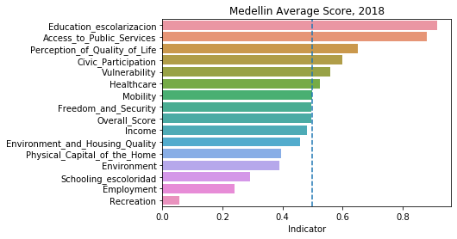

**Figure 1:** *Medellín’s mean performance**on each of the 15 indicators, 2018*

**Improvement**

In the period from 2011-2018, there was a small improvement on most indicators, except a critical few. This would indicate Medellín is progressing towards becoming a healthier city in terms of the social determinants of health. As shown in Figure 2, the percentage change in score from 2011-2018 was large and positive for civic participation and income. However, environment and employment indicators declined in performance over time, along with the recreation indicator, which had such a substantial decline that it could not be clearly visualized on the same scale as the other indicators. Most of the indicators showed only small changes (less than five percent). If Medellín is interested in more closely monitoring its performance, it could consider choosing intermediate indicators that show greater change year-on-year, to give more immediate feedback on progress.

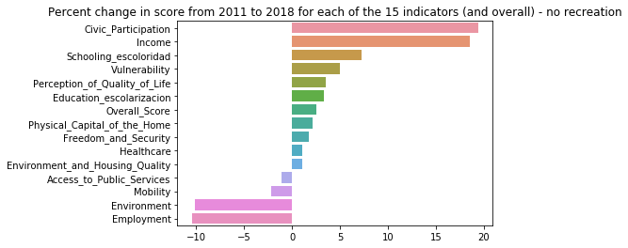

**Figure 2:** *Percent change in Medellín average score from 2011 to 2018 for each indicator\**

*\*Recreation was excluded because it decreased so substantially (>300% decline) that it couldn’t be displayed meaningfully on the same scale as the other variables*

**Spatial Equity**

Before analyzing the results according to spatial equity, it is important to understand the

comuna and estrato system operating in Medellín. As Figure 3 illustrates, the average estrato (socioeconomic level) differs substantially between each comuna (district) in the city. The highest performing comunas by estrato are #14 (southern tip of the city), and #11 (west). The lowest-performing comunas are comuna #1 and #2 (north east of the city). Comunas receiving the PUI investment were comunas 1, 2 and 13.

|  |  |  |
| --- | --- | --- |
|  | Average estrato for each comuna (2018) |  |

**Figure 3:** *Comunas of Medellín - A) Name, number and location of each comuna (district) in Medellín (source:* [*www.Medellín.gov.co*](http://www.medellin.gov.co/)*), B) Average estrato (socioeconomic level) for each comuna in 2018, in which 6 is the highest (dark blue) and 1 is the lowest (white), C) Table showing the four top and bottom performing comunas in terms of estrato.*

There is inequality between comunas on their overall score across all indicators that closely maps to their estrato. This is seen in the moving image (gif) in Figure 4. Well-off comunas (e.g. comuna 14, south, and comuna 11, mid-west) have the darkest blue, indicating the highest overall score. While there is a small degree of improvement over time within some comunas (as seen by the darkening of the blue from 2011 - 2018), there is little to no convergence between the scores of each comuna (i.e. the improvement in one comuna is insufficient to bring them to the level of a higher performing comuna). This indicates persistent spatial inequality in the city.



**Figure 4:** *Overall score for each comuna in the city, 2011 to 2018 (video). Scores range from 0 (minimum; white) to 1 (maximum; dark blue). Each block is a different comuna in the city of Medellín.*

Figure 5 maps performance across all comunas on all indicators. It shows that the gap in performance is greater between indicators than it is between comunas (on the chart, the difference in color is bigger between indicators than between comunas on the same indicator). This would indicate that Medellín is more equal than we might have thought. However, some indicators have large spatial diversity in outcomes, namely: housing quality, vulnerability, and income. Medellín should focus on reducing spatial inequity on these indicators.

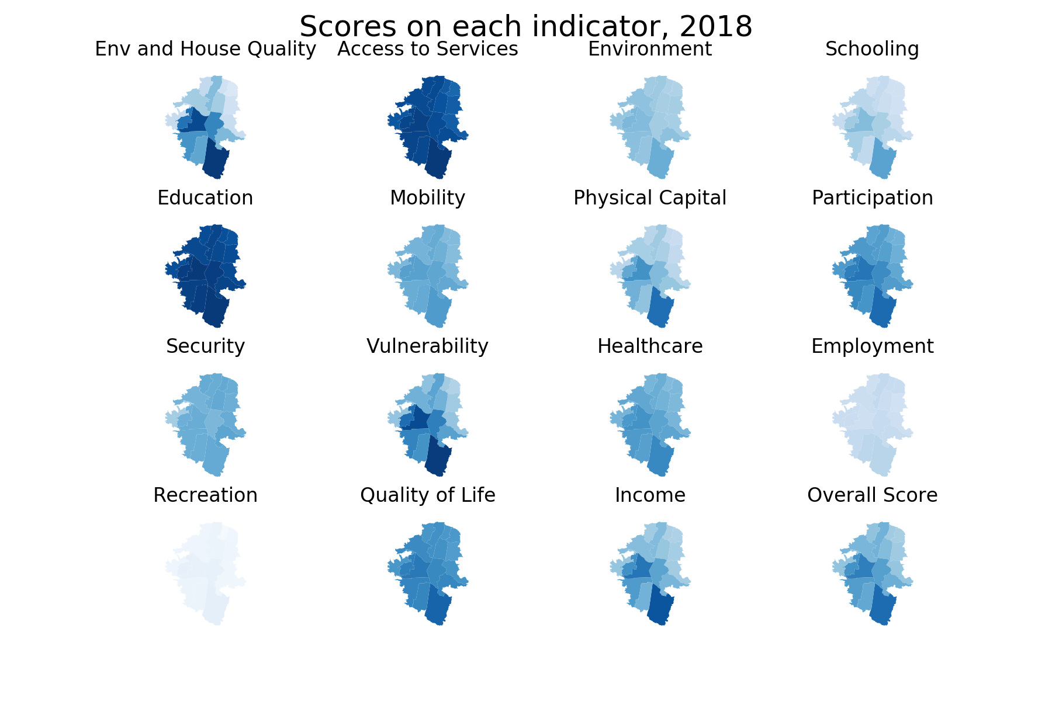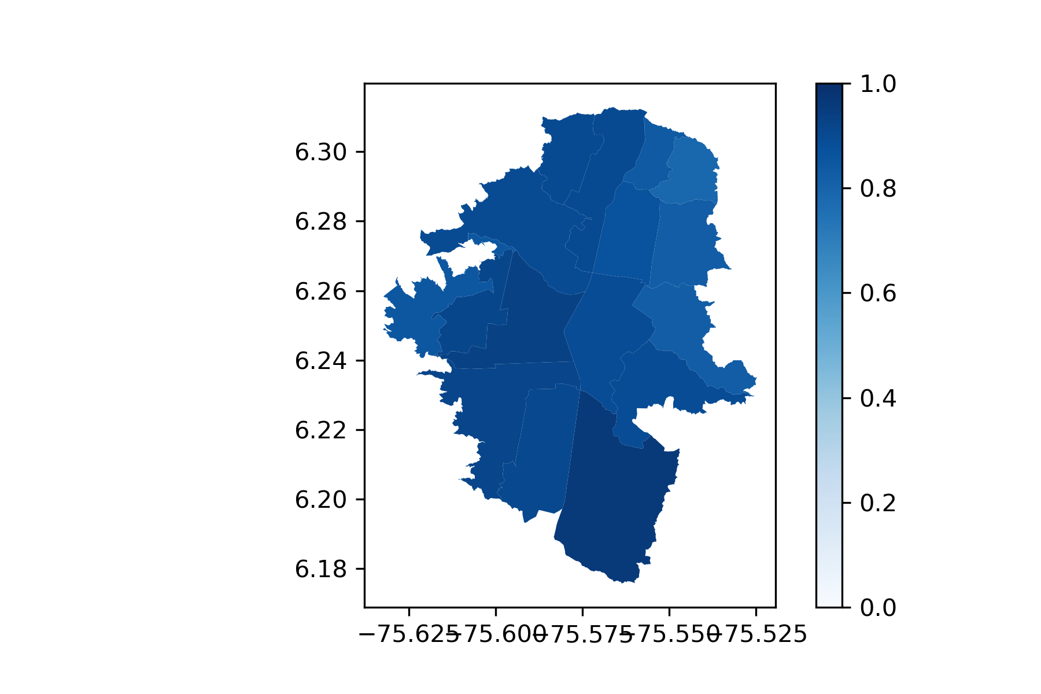

**Figure 5:** *Map of scores on each indicator, 2018*

**Gender equality**

There doesn’t appear to be a divide between men and women in self-reportedquality of life or health, as seen in Figure 6.[3] Further analysis is required to see if outcomes differ by sex on objective standards.

|  |  |
| --- | --- |
|  |  |

**Figure 6:** *Self-reported scores on overall health and quality of life, on a five-point scale in which 1 is the lowest and 5 is the highest. Breakdown by sex shows no significant difference between men and women.*

**Equality by estrato**

There doesn’t appear to be a statistically significant difference between people of different estratos (socio-economic levels) in *self-reported* health, although there is a small (not statistically significant) increase as socio-economic level rises, as seen in Figure 7.[4] Further analysis is required to see if outcomes differ by estrato on objective standards.

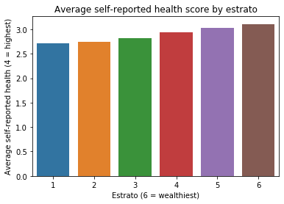

**Figure 7:** *Average self-reported health by estrato (socio-economic level)*

**Closing the gap in spatial inequality**

Spatial equity is improving: poorer comunas are improving at a faster rate relative to the Medellín mean than wealthier neighbourhoods, and the gap in outcomes is shrinking. This is a strong indicator of moves in the right direction for Medellín becoming a healthier city.

Figure 8 shows the deviation in overall score between comunas. Following the methodology set out by Millan and Creutzig in their 2016 paper[5], we compare each comuna to the Medellín average to understand the spatial equity in performance on each indicator. We calculate a ‘deviation’ score, which is the ratio between the comuna’s score and the Medellín average score (subtracted by 1 to center it around 0). This gives a value below or above zero, where negative scores indicate that the comuna performs worse than the Medellín average, while positive values indicate the comuna outperforms the Medellín average. The deviation in overall score for each comuna in 2011 is shown in Figure 8a. We then calculate the percentage change in deviation over the period from 2011 to 2018. Negative percentage changes in deviation indicate that the comuna’s score got worse compared to the Medellín mean over the eight-year period, while positive changes suggests that the comuna’s improvement outperformed the Medellín mean.

If Medellín cares about spatial equity in performance (as we know it does), then we would hope for small deviation between comunas in Figure 8a. We see, as expected, that the wealthier comunas (e.g. comuna 14, comuna 11) perform the highest above the Medellín mean.

If Medellín is to close the gap in performance between comunas and create a more equal society, we would hope to see that comunas that performed below average in 2011 (blue) have the largest (positive) change in deviation, while those comunas that were performing well in 2011 (orange) have a decline in deviation. In general, this is what we see happen in Figure 8b. The “blue: comunas (the underperformers in 2011) have the largest increase in their performance relative to the Medellín mean. In other words, performance is converging and the gap between poor and wealthy comunas is narrowing. The comuna with the highest percentage change in deviation is comuna 13, which has been a traditionally poor neighborhood that has received substantial infrastructure investment (e.g. the metrocable and PUI projects) in recent years. While no causal inferences can be drawn from this chart, it would appear that Medellín’s attention on spatial equity has been paying off.

|  |  |
| --- | --- |
|  |  |

**Figure 8:** *A) Each comuna’s deviation from the Medellín mean for the Overall Score across all fifteen indicators at 2011 (values below zero indicate the comuna’s score is below the Medellín mean, while values above 1 indicate the comuna is above the Medellín mean). B) The percent change in deviation from the Medellín mean from 2011 - 2018 (values below zero indicate that the comuna’s score got worse compared to the Medellín mean, values above zero indicate the comuna’s score improved relative to the Medellín mean). Orange indicates that the comuna performed above the Medellín mean in 2011, while blue indicates their 2011 score was below the Medellín mean.*

1. <http://medata.gov.co/dataset/%C3%ADndice-multidimensional-encuesta-calidad-de-vida>
2. <http://medata.gov.co/medell%C3%ADn-en-cifras/indice-multidimensional-de-condiciones-de-vida-imcv-2011-2017>)
3. Due to limitations in data availability, we were unable to easily measure gender differences on overall scores on each indicator.
4. Due to limitations in data availability, we were unable to easily measure socioeconomic level differences on overall scores on each indicator.
5. Fernandez Milan, B., & Creutzig, F. (2016). Participatory design in transit-oriented development uncovers social benefits. doi: *10.14279/depositonce-5521*.